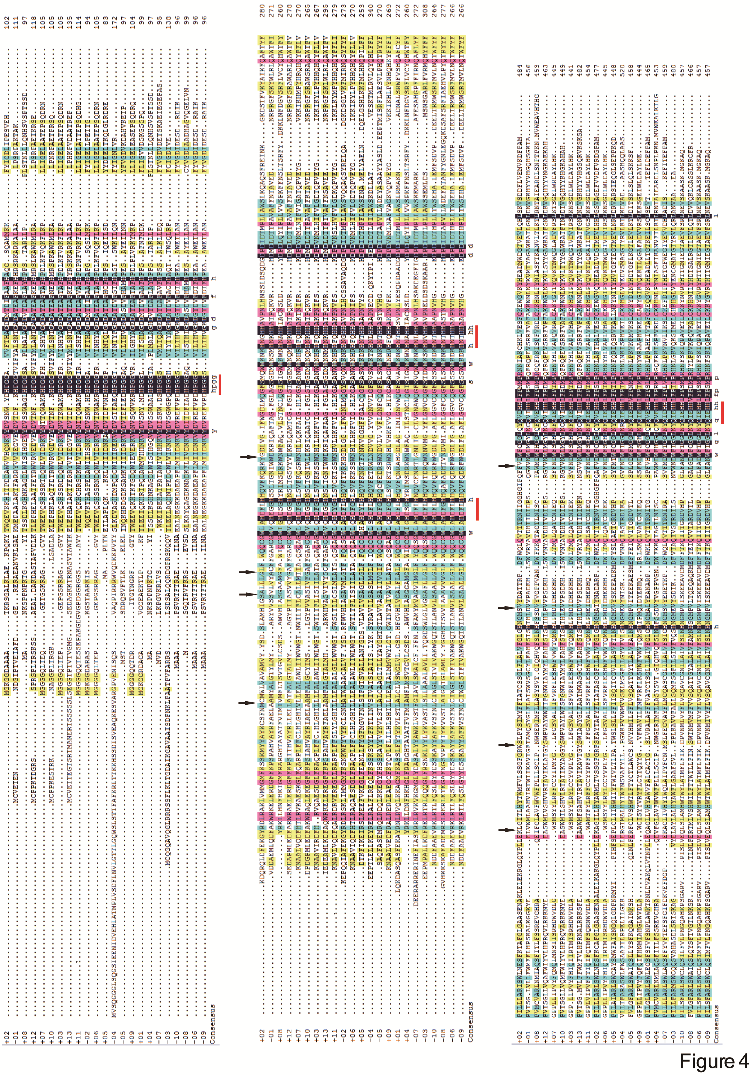
Supplemental Figure S1 Multiple Sequence alignment of deduced amino acids for GcFADS6 (+1) and TpFADS6 (+2) with FADS6s from other species, including Ostreococcus tauri (-1), Psetta maximus (+8), Oncorhynchus mykiss (+12), Sparus aurata (+7), Cyprinus carpio (+10), Acanthopagrus schlegeli (+3), Micromonas pusilla CCMP1545 (+13), Mantoniella squamata (+11), Phaeodactylum tricornutum (-2), Mucor rouxii (+6), Conidiobolus obscurus (+5) Ceratodon purpureus (-4), Rhizopus arrhizus (-5), Primula vialii (+9), , Primula farinosa (+4), Pythium irregulare (-7), Parietochloris incisa(-3), Mortierella fungus ATCC32222 (-10), Mortierella fungus 1S-4 (-8), Cunninghamella echinulata (-6) and Mortierella alpina W15 (-9) using ClustalX. These sequences were ordered according to their catalytic efficiency of ALA substrate. Red lines, black arrows and “+” & “-” were used as described previously .

1. Shi, H., et al., Molecular mechanism of substrate specificity for delta 6 desaturase from Mortierella alpina and Micromonas pusilla. Journal of Lipid Research, 2015. 56(12): p. 2309-2321.

